**TECHNICAL BRIEF**

**ENGR 131- Solar Energy Viability**

Section 02

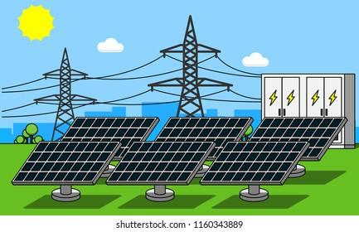

(Markova, 2020)

Team 25

Samuel Morales, Luca Rosu, Kyle Johnson, Mathew Jacobs

Date: 9/20/2021

Contents

I. TEAM MEMBER ROLES 3

II. PROBLEM STATEMENT 4

III. BACKGROUND INFORMATION 4

IV. ECONOMIC AND ENVIRONMENTAL ANALYSES 7

a. Economic Analysis 7

b. Environmental Analysis 9

V. RECOMMENDATIONS TO THE MAYOR 13

VI. REFERENCES 14

VII. APPENDICES 15

# TEAM MEMBER ROLES

|  |  |  |  |
| --- | --- | --- | --- |
| **Team Member Name** | **Task(s)** | **Due Date(s)** | **Status** (pending, on time, etc.) |
| Luca Rosu | * Problem Statement | * 9/19/2021 | On Time |
| Kyle Johonson | * Introduction/Context | * 9/19/2021 | On Time |
| Samuel Morales | * Economic Analysis | * 9/19/2021 | On time |
| Matthew Jacobs | * Environmental Analysis | * 9/19/2021 | On Time |
| Other tasks that required all-team discussion | * Recommendation to the mayor * Excel Spreadsheets | * 9/19/2021 | On Time |

# PROBLEM STATEMENT

The mayor of the city of Indianapolis has commissioned us to research the viability of installing a solar panel array on the top of the Indianapolis public library. Due to the rising costs of energy, and the need to reduce greenhouse gas emissions, the client wants to decrease the library's reliance on conventional energy systems. The currently proposed solution is constrained to the 1,000 square meters of available roof space, as well as the need to mount the solar panels flat on the roof to prevent them from being an eyesore from the ground. The proposed system must also produce 393,434kW per year to meet the building's electricity needs. In terms of our criteria, It would be beneficial to the viability of the project if the return on investment was under 20 years.

# BACKGROUND INFORMATION

The Indianapolis Public Library is a two-story building with a total of 5,200 $m^{2}$. The library consumes 393,434 kWh per year but varies depending on season at a latitude of 39.73°. The library currently purchases energy at a rate of 9.77 cents per kWh and is seeking alternative solutions due to rising costs. Currently the library uses electricity to run computers, electronics, lights, and ventilation systems. Furnaces use natural gas for heating during winter and to provide hot water year-round.

Energy use distribution can be seen in the following figure

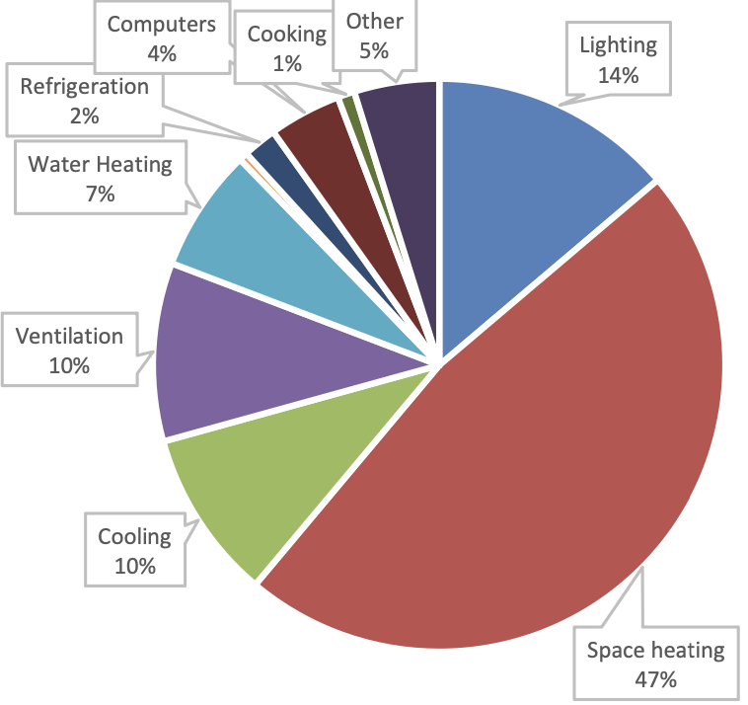

Figure 1. Energy Distribution of the library

Because the public library is located at a latitude of 39.73°, it experiences varying levels of daily solar insolation, natural gas consumption, and electricity consumption depending on the season. During the colder months the library consumes far more natural gas to provide heat to the building, consumes far less electricity, and has a much lower daily solar insolation. During the warmer months the library consumes more electricity and has a much higher daily solar insolation. The actual solar insolation per day will vary depending on weather, cloud cover, time of day, and angle of tilt between the solar panel and the sun. We would need to assume solar panels are installed flat for these calculations. By assuming flat panel installation, we can use the summary of daily statistics to understand the effect of solar panel installation. A figure containing a detailed monthly description of these is provided in Table 1. Monthly data

Table 1. Monthly data

|  |  |  |  |  |
| --- | --- | --- | --- | --- |
| **Month** | **Days per Month** | **Natural Gas Consumption (cubic ft)** | **Electricity Consumption (kWh)** | **Average Daily Solar Insolation (kWh/day*m^2)** |
| January | 31 | 174,618 | 28888 | 2 |
| February | 28 | 156,791 | 28901 | 2.8 |
| March | 31 | 112,141 | 29037 | 3.7 |
| April | 30 | 66,066 | 29984 | 4.9 |
| May | 31 | 40,628 | 33812 | 5.9 |
| June | 30 | 23,777 | 39399 | 6.5 |
| July | 31 | 23,696 | 39480 | 6.3 |
| August | 31 | 23,207 | 39994 | 5.6 |
| September | 30 | 31,022 | 35868 | 4.6 |
| October | 31 | 63,380 | 30173 | 3.3 |
| November | 30 | 109,485 | 28996 | 2.1 |
| December | 31 | 134,323 | 28901 | 1.6 |

In terms of solar panels, the cost of installation includes costs of materials, pre-installation fees, installation/labor, government incentives and maintenance. We assume that the life of solar panels is expected to be 20 years and that we need to install 500 solar panels (as requested by the client). The cost of the solar panels is shown below in Table 2. Cost of solar panels

Table 2. Cost of solar panels

|  |  |
| --- | --- |
| **Costs** | |
| Item (c/u) | Amount |
| Solar Panel | $238 |
| System hardware and wiring | $150 |
| Installation and labor fees | $200 |
| Lifetime Maintenance | $12 |
| Total cost | $600 |
| 500 Solar panel installation cost | $300,000 |

When calculating the energy that can be produced by the proposed solar panel array, there are certain panel constraints that need to be considered. One of which is the efficiency of the panels which due to current technology is limited to 22% of solar insolation.

Further constraints are shown below in Table 3. Solar Panel energy production data**.**

Table 3. Solar Panel energy production data

|  |  |
| --- | --- |
| **Solar Panel Specs (SM 245 solar panel)** | |
| Energy Efficiency | 22% of solar insolation |
| Area | 1.675 $m^{2}$ per panel |
| Weight | 48.5 lbs per panel |

The equation used to calculate the energy produced was given by our client, and is the following:

$$Energy Produced by Solar Panels = Mean Daily Insolation ×Panel Efficiency × Panel area ×\frac{Days}{Months}$$

C02 Emissions of our three sources of energy: Natural Gas and Electricity. Our team will not consider any emission of C02 generated by the solar panel because the panels do not produce C02 (GVEC Solar Services, 2020).

The data is shown in the following Table 4. Carbon emission of energy sources

Table 4. Carbon emission of energy sources

|  |  |
| --- | --- |
| **Carbon Emissions** | **Amount** |
| Per cubic foot of Natural Gas | .0548 kg of CO2[1] |
| Per kWh | .417 kg of CO2[2] |

# ECONOMIC AND ENVIRONMENTAL ANALYSES

## Economic Analysis

For the economic analysis, the total capital investment was calculated by first calculating the individual price of one panel and then multiplying it by 500 (the number of panels we are considering). The total cost of one panel with hardware and installation is $600[3], making the capital investment of the new system $300,000.

In terms of payback period, we used the capital investment as our investment value. For the savings part we considered the difference between the cost of a year of electricity with the current system and the cost of the proposed system. To calculate the first, we add up the monthly electricity of the current system and multiply it by the electricity rate given. For the second value, we calculated the electricity generated by the solar panels per month and then calculated the difference of the total electricity needed and the electricity produced by the solar panels. This would give us the electricity that the library still needs to buy, so multiply this value by the cost of electricity. After doing all the calculations, the payback-time of the investment was 11.1 years.

For the final calculation, we first calculated the total saving per year by dividing the total investment by the desired payback-time. This turned out to be $100,000. With this value in mind, we created a formula that calculates the total money spent in both the current and proposed system based on the amount of energy needed. Then we expressed the money spent on the current system and the proposed system as a linear equation in terms of energy and price of energy, then we solved the system for our only variable, price of energy. The new price would be $0.361 which is an acceptable result due to the higher cost efficiency of the new system.

All the results of the research are annotated in the following table:

Table 5. Calculated results

|  |  |
| --- | --- |
|  | Calculations |
| Total capital investment of new system ($) | 300,000 |
| Payback period for capital investment (years) | 11.1 |
| Price of electricity with a 3-year payback yield ($/kWh) | 0.361 |

In Figure 2, we present a comparison of the monthly commercial energy purchased (in kWh) with the **current** system, and the monthly commercial energy purchased (in kWh) with the **proposed** solar panels.

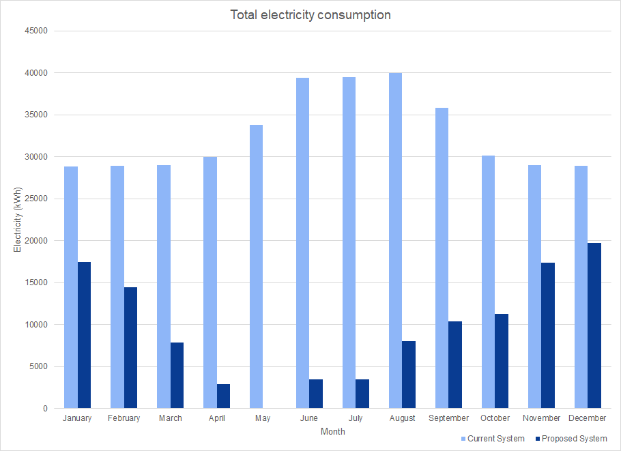

Figure 2. Monthly electricity consumption of both systems (kWh)

In Figure 3, we present a comparison of the cost of the monthly commercial energy purchased (in dollars) with the **current** system, and the cost of the monthly commercial energy purchased (in dollars) with the **proposed** solar panels.

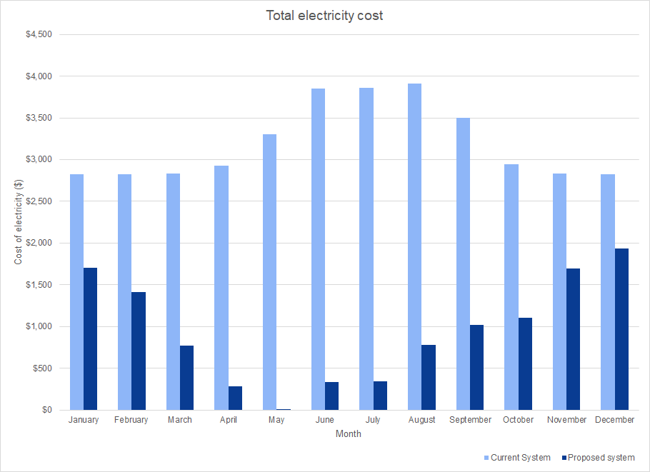

Figure 3. Monthly commercial energy purchased ($)

The results are favorable for the installation of solar panels. The pay-back period of 11.1 years is an acceptable amount of time considering the lifetime of solar panels to be 20 years. Meaning that we can save almost twice as much as the investment value in 20 years. In terms of electricity generation, solar panels reduce the demand for electricity every month, even providing all the energy required in the summer months. This means, solar panels are a great source of energy. In consequence, the amount of money spent on electricity is also reduced, meaning the library will spend less money on electricity, with the spending in some summer months being close to $0, and even in the winter season (when solar insolation is minimized), the solar panels are still able to contribute around 25% of the required energy. In summary, solar panels are a viable option for a long-term investment.

## Environmental Analysis

In order to make sure that the proposed system would have been a positive change for the environment we needed to find the CO2 produced with the current system and the CO2 that would be produced by the proposed system. In order to calculate the CO2 emissions of the current system we needed to take into account the CO2 created by burning natural gas, the kW of electricity purchased and the amount of CO2/kWH which yielded the amount of CO2 of the current system.

To find the CO2 of the proposed system the calculations are very similar with the only difference being the amount of electricity that the library buys. To find the new amount of electricity bought, the amount of electricity produced by the panels needs to be subtracted from the total electricity that the library needs, with the calculations being performed with the new number.

**Figure 4** models monthly CO2 emissions from natural gas usage, the emissions from electricity, and the total CO2 emissions of the library. In the colder months we can see that the CO2 emissions for natural gas are much higher than in the warmer months due to the increased usage of the heaters. While the CO2 produced from electricity is mirrored in the summer months when the use of air conditioning would consume much more electricity. The total C02 emitted is still much lower during the summer because there is no natural gas being used, therefore the CO2 emissions are much lower. 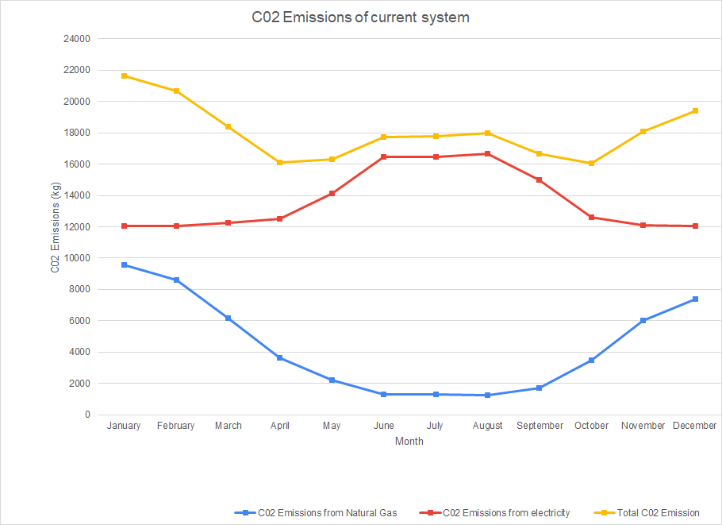

Figure 4. CO2 emissions from energy use with current fossil energy

**Figure 5** models monthly CO2 emissions from natural gas usage, the emissions from electricity with the solar panels installed, and the total CO2 emissions of the library.

Even though the natural gas usage of the library is the same with the proposed system as with the current system, the total CO2 emissions are much lower. The difference in the total energy used comes from the CO2 emissions from electricity which are much lower than in **fig.4.** As seen in **fig.5** the emissions from electricity are higher in the winter than in the summer which is due to the lower solar insolation in the winter. When the summer sun emerges the solar panels start to produce enough electricity to counteract the increased usage of the AC systems which results in much lower overall CO2 emissions than the current system.

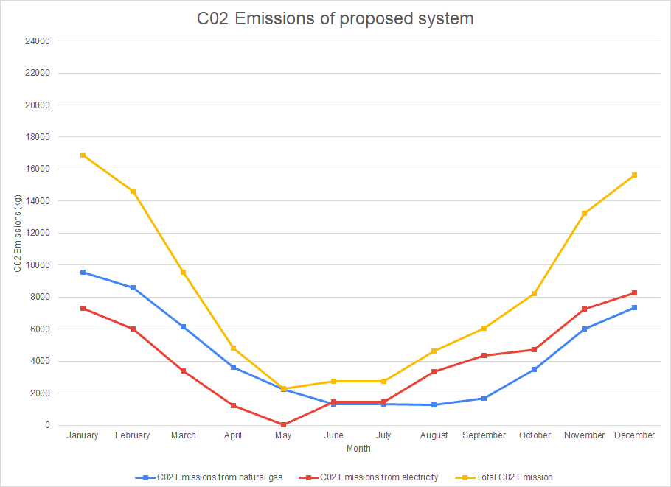

Figure 5. CO2 emissions from energy use with solar panel installation

Now, we will show the share of emissions in both the current system and the proposed system. We considered the total emissions to be the January pre-installation C02 Emission so that we can make a comparison in terms of the reduction in emissions. In Figure 6 you can see both graphs.

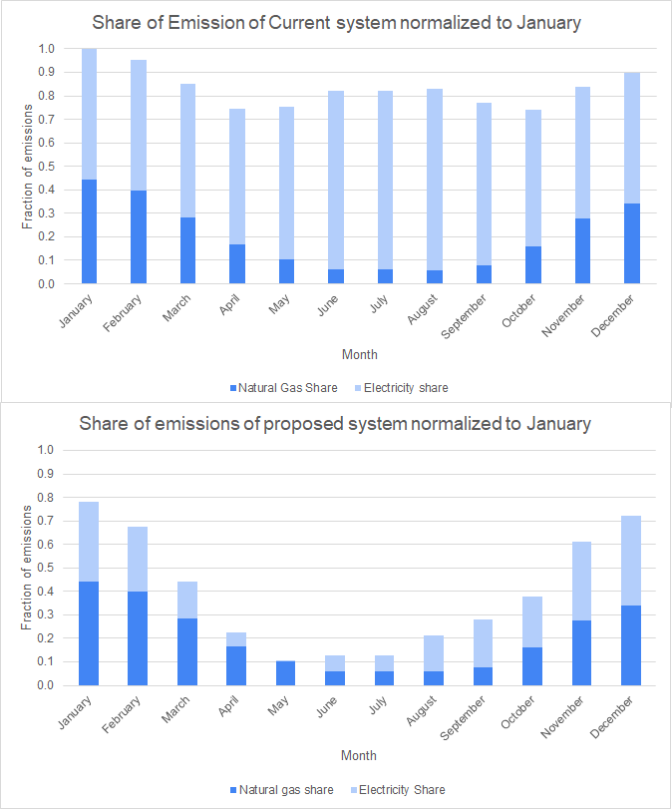

Figure 6. Share of C02 Emissions in proposed and current system.

# RECOMMENDATIONS TO THE MAYOR

The proposed new system is a viable, long term option for the library’s energy and environmental needs. Even though the solar panels are not going to be able to generate all the electricity needed, they are still able to considerably reduce the amount spent on electricity. The price of installation is one of the biggest factors to consider, with the upfront investment being $300,000 for 500 panels with a proposed lifecycle of 20 years. Even though the upfront cost may be high, the proposed system would have a return on investment of 11.1 years, so the total savings the proposed system generates after the 20 years will be around $600,000. Which in the long run could end up being more if the price of electricity increases. If the library has the required funding methods to install the solar panels, the economic analysis suggests that the array should be installed.

In terms of the environment, the amount of C02 produced by the proposed system is reduced by around 56% (see **Figure 6**), this means that the library would reduce their carbon footprint from electricity consumption by almost a half. This is a positive result, but it does not fully eliminate the carbon footprint of the library, meaning that researching other alternative sources of energy might yield better environmental results.

In conclusion, our team recommended to the mayor to install the solar panels if the library has the needed funding. From both environmental and economic analysis, the solar panels present an upgrade in efficiency.

# REFERENCES

Environmental Protection Agency. (2020). *Greenhouse Gases Equivalencies Calculator - Calculations and References*. Retrieved from EPA: https://www.epa.gov/energy/greenhouse-gases-equivalencies-calculator-calculations-and-references#:~:text=The%20average%20carbon%20dioxide%20coefficient,cubic%20foot%20(EIA%202019c)

GVEC Solar Services. (2020). *How Clean Is The Solar Panel Manufacturing Process?How Much Carbon Dioxide Is Produced?* Retrieved from GVEC: https://gvecsolarservice.com/how-clean-is-the-solar-panel-manufacturing-process-how-much-carbon-dioxide-is-produced/#:~:text=Accounting%20for%20the%20amount%20of,of%20coal-powered%20electricity%20sources

Markova, Y. (2020). *Solar Power Station with Battery Storage [PNG].* Retrieved from https://www.shutterstock.com/image-vector/solar-power-station-battery-storage-cartoon-1160343889

U.S. Energy Information Administration. (2020, December 15). *Frequently asked questions (faqs)*. Retrieved from EIA: https://www.eia.gov/tools/faqs/faq.php?id=74&t=11

# APPENDICES

For details of our analyses please refer to the Excel file, named: ENGR131_ A05 _25.xlsx

1. (Environmental Protection Agency, 2020)
2. (U.S. Energy Information Administration, 2020)
3. See appendix for calculations